实验二 线程与同步
- 实验目的
实现Nachos的同步机制：锁和条件变量，并利用这些同步机制实现一些工具类。
- 实验内容
（1）实现锁机制和条件变量
（2）实现一个线程安全的表结构
（3）实现一个大小受限的缓冲区
- 实验步骤
3.1实现锁机制和条件变量
- 用Thread::Sleep实现锁机制和条件变量
对synch.h做一下修改后保存为synch-sleep.h：
class Lock {
public:
Lock(char* debugName,int initialValue); // initialize lock to be FREE
~Lock(); // deallocate lock
char* getName() { return name; } // debugging assist

void Acquire(); // these are the only operations on a lock
void Release(); // they are both *atomic*

bool isHeldByCurrentThread(); // true if the current thread
// holds this lock. Useful for
// checking in Release, and in
// Condition variable ops below.

private:
char* name;
int value;
List *queue;
Thread *current;
// for debugging
// plus some other stuff you'll need to define
};
class Condition {
public:
Condition(char* debugName); // initialize condition to
// "no one waiting"
~Condition(); // deallocate the condition
char* getName() { return (name); }

void Wait(Lock *conditionLock); // these are the 3 operations on
// condition variables; releasing the
// lock and going to sleep are
// *atomic* in Wait()
void Signal(Lock *conditionLock); // conditionLock must be held by
void Broadcast(Lock *conditionLock);// the currentThread for all of
// these operations

private:
char* name;
List *queue;
// plus some other stuff you'll need to define
};
对synch.cc进行修改，实现其中未实现的函数，保存为synch-sleep.cc：
Lock::Lock(char* debugName,int initialValue)
{
name = debugName;
value = initialValue;
queue = new List;
}
Lock::~Lock()
{
delete queue;
}
void Lock::Acquire()
{
IntStatus oldLevel = interrupt->SetLevel(IntOff);

while (value == 0)
{ // semaphore not available
queue->Append((void *)currentThread);
currentThread->Sleep();
}
value--;
current=currentThread;
(void) interrupt->SetLevel(oldLevel);
}
void Lock::Release()
{
Thread *thread;
ASSERT(isHeldByCurrentThread()==true);
IntStatus oldLevel = interrupt->SetLevel(IntOff);

thread = (Thread *)queue->Remove();
if (thread != NULL)
scheduler->ReadyToRun(thread);
value++;
(void) interrupt->SetLevel(oldLevel);

}
bool Lock::isHeldByCurrentThread()
{
if (current == currentThread && value==0)
return true;
return false;

}

Condition::Condition(char* debugName)
{
name = debugName;
queue = new List;
}
Condition::~Condition()
{
delete queue;
}
void Condition::Wait(Lock* conditionLock)
{
IntStatus oldLevel = interrupt->SetLevel(IntOff);
conditionLock->Release();
queue->Append((void *) currentThread);
currentThread->Sleep();

(void) interrupt->SetLevel(oldLevel);
conditionLock->Acquire();

}
void Condition::Signal(Lock* conditionLock)
{
ASSERT(conditionLock->isHeldByCurrentThread()==true);
Thread *thread = (Thread *) queue->Remove();

if (thread != NULL)
scheduler->ReadyToRun(thread);

}
void Condition::Broadcast(Lock* conditionLock)
{
ASSERT(conditionLock->isHeldByCurrentThread() == true);
Thread *thread;
while ((thread = (Thread *) queue->Remove()) != NULL)
scheduler->ReadyToRun(thread);
}
- 用Semaphore实现锁机制和条件变量
对synch.h做一下修改后保存为synch-sem.h：
class Lock {
public:
Lock(char* debugName,int initialValue); // initialize lock to be FREE
~Lock(); // deallocate lock
char* getName() { return name; } // debugging assist

void Acquire(); // these are the only operations on a lock
void Release(); // they are both *atomic*

bool isHeldByCurrentThread(); // true if the current thread
// holds this lock. Useful for
// checking in Release, and in
// Condition variable ops below.

private:
char* name;
Semaphore *sem;
Thread *current;
// for debugging
// plus some other stuff you'll need to define
};
class Condition {
public:
Condition(char* debugName); // initialize condition to
// "no one waiting"
~Condition(); // deallocate the condition
char* getName() { return (name); }

void Wait(Lock *conditionLock); // these are the 3 operations on
// condition variables; releasing the
// lock and going to sleep are
// *atomic* in Wait()
void Signal(Lock *conditionLock); // conditionLock must be held by
void Broadcast(Lock *conditionLock);// the currentThread for all of
// these operations

private:
char* name;
int value;
Semaphore *sem;
// plus some other stuff you'll need to define
};
对synch.cc进行修改，实现其中未实现的函数，保存为synch-sem.cc：
void Lock::Acquire()
{
IntStatus oldLevel = interrupt->SetLevel(IntOff);
sem->P();
current=currentThread;
(void) interrupt->SetLevel(oldLevel);
}
void Lock::Release()
{
ASSERT(isHeldByCurrentThread()==true);
IntStatus oldLevel = interrupt->SetLevel(IntOff);
sem->V();
current = NULL;
(void) interrupt->SetLevel(oldLevel);

}
bool Lock::isHeldByCurrentThread()
{
if (current == currentThread)
return true;
return false;

}

Condition::Condition(char* debugName)
{
name = debugName;
value = 0;
sem = new Semaphore(debugName,0);
}
Condition::~Condition()
{
delete sem;
}
void Condition::Wait(Lock* conditionLock)
{
IntStatus oldLevel = interrupt->SetLevel(IntOff);
conditionLock->Release();
sem->P();
value++;
(void) interrupt->SetLevel(oldLevel);
conditionLock->Acquire();

}
void Condition::Signal(Lock* conditionLock)
{
ASSERT(conditionLock->isHeldByCurrentThread()==true);
IntStatus oldLevel = interrupt->SetLevel(IntOff);
if (value>0)
{
sem->V();
value++;
}
(void) interrupt->SetLevel(oldLevel);

}
void Condition::Broadcast(Lock* conditionLock)
{
ASSERT(conditionLock->isHeldByCurrentThread() == true);
IntStatus oldLevel = interrupt->SetLevel(IntOff);
while (value > 0)
{
sem->V();
value--;
}
(void) interrupt->SetLevel(oldLevel);
}
3.2实现一个线程安全的表结构
根据Table.h在Table.cc中实现相关函数：
Table::Table(int size)
{
elem = new void *[size + 1];
memset(elem, 0, sizeof(void *) * (size + 1));
lock = new Lock("Table lock",1);
table_size = size + 1;
}

Table::~Table()
{
delete elem;
delete lock;
}

int Table::Alloc(void *object)
{
if (object == NULL)
return 0;

int index = 0;
lock->Acquire();
for (int i = 1; i < table_size; i++)
if (elem[i] == NULL)
{
index = i;
break;
}
currentThread->Yield();
if (index != 0)
{
elem[index] = object;
}
else
index = -1;
lock->Release();
return index;
}

void* Table::Get(int index)
{
ASSERT((index >= 0) && (index < table_size));
return elem[index];
}

void Table::Release(int index)
{
ASSERT((index >= 0) && (index < table_size));
elem[index] = NULL;
}
在threadtest.cc添加测试函数：
Table table(10);
void TableThread(int which)
{
int user[4], i;
for (i = 0; i < 4; i++)
{
void *obj = (void *)(rand() % 100 + 1);
printf( "Thread %d save %d\n", which, (int) obj);
user[i] = table.Alloc(obj);
printf( "Thread %d xishu = %d\n", which, user[i]);
currentThread->Yield();
}
for (i = 0; i < 4; i++)
printf("Thread %d: table[%d] == %d\n", which, user[i], (int) table.Get(user[i]));
for (i = 0; i < 4; i++)
{
printf("Thread %d delete table[%d]\n", which, user[i]);
table.Release(user[i]);
printf("Thread %d: option succeed!\n", which);
currentThread->Yield();
}
}

void TableTest()
{
Thread *t = new Thread("forked thread");
t->Fork(TableThread, 1);
TableThread(0);
}
3.3实现一个大小受限的缓冲区
参考书本中的生产者消费者问题的代码在BoundedBuffer.cc中实现BoundedBuffer.h中的函数：
BoundedBuffer::BoundedBuffer(int maxsize)
{
buffer_size = maxsize;
buffer = (char *) malloc(maxsize);
cond = new Condition("cond");
notfull = new Lock("notfull",1);
notempty = new Lock("notempty",1);
read_pos = write_pos = 0;
count = 0;
}

BoundedBuffer::~BoundedBuffer()
{
delete notfull;
delete notempty;
delete cond;
free(buffer);
}

void BoundedBuffer::Read(void *data, int size)
{
char *out_buf = (char *) data;
while (size--)
{
notempty->Acquire();
while (count == 0)
cond->Wait(notempty);
notempty->Release();
*(out_buf++) = buffer[read_pos];
read_pos = (read_pos + 1) % buffer_size;
notfull->Acquire();
--count;
cond->Signal(notfull);
notfull->Release();
}
}

void BoundedBuffer::Write(void *data, int size)
{
char *in_buf = (char *) data;
while(size--)
{
notfull->Acquire();
while (count >= buffer_size)
cond->Wait(notfull);
notfull->Release();
buffer[write_pos] = *(in_buf++);
write_pos = (write_pos + 1) % buffer_size;
notempty->Acquire();
++count;
cond->Signal(notempty);
notempty->Release();
}
}
在thread.cc中添加测试函数：
BoundedBuffer bbuff(3);

void bbuffThread(int x)
{
char buf[2] = "A";
for (int i = 0; i < 20; i++)
{
printf("Producer: write %s\n", buf);
bbuff.Write(buf, 1);
++buf[0];
}
}

void BoundedBufferTest()
{
Thread *t = new Thread("forked thread");
t->Fork(bbuffThread, 1);

for (int i = 0; i < 10; i++)
{
char buf[3] = { 0 };
bbuff.Read(buf, 2);
printf("Consumer: read %s\n", buf);
}
}
- 实验结果
- 实现锁机制和条件变量
在没有使用互斥机制的情况下，其中在进程切换后会插入会出现错误：
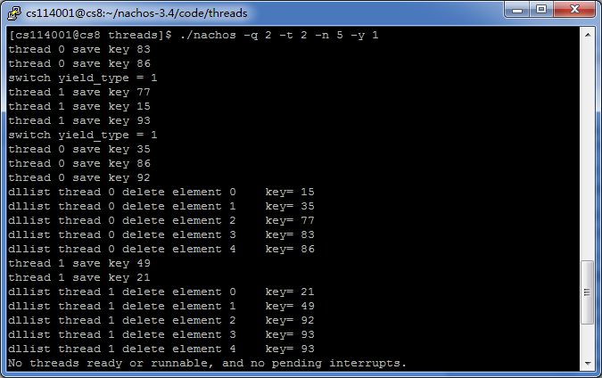
在使用seelp方法和Semaphore方法实现的互斥机制后，进程是安全的：
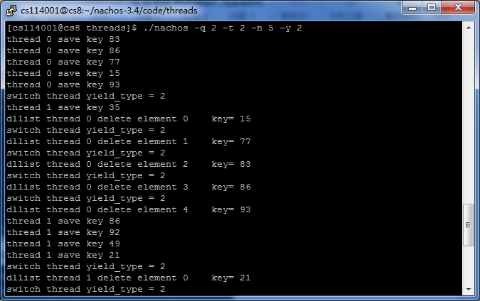
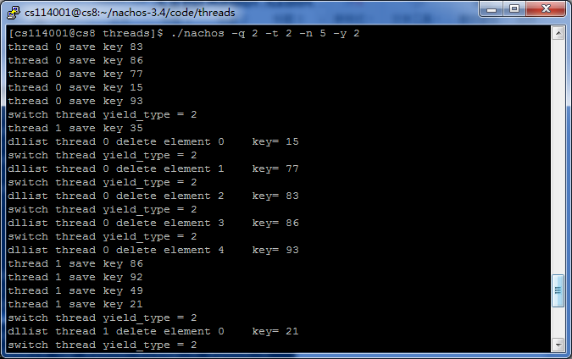
- 实现一个线程安全的表结构
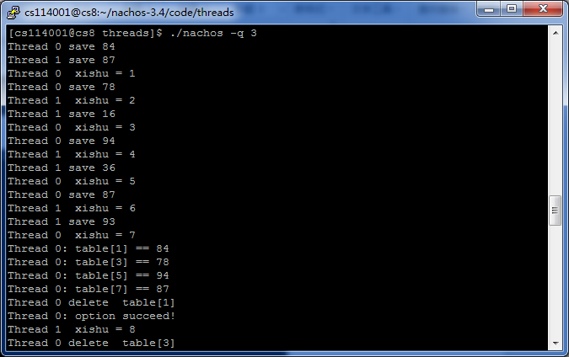
（3）实现一个大小受限的缓冲区
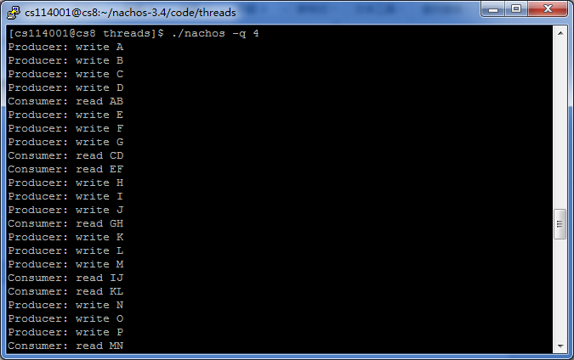
- 心得体会
在做本次实验过程算是把书本相关知识又复习了一遍。通过动手做实验，我们对锁、中断、条件变量等概念有了更深的认识。不过写程序的过程还是让人蛋疼的。比如在实现Lock类时，我加入了一个value属性，并在初始化函数中以参数的形式初始化。某个文件使用了，Lock(char* debugName)，而这个函数被我删掉，所以一直编译不过。由于粗心，没有发现原因，修改了很久。也不是很确定自己的这种互斥机制对不对。勉强算完成实验了吧！

